**24: ONLINE STOCK MONITORING SYSTEM**

**USE CASE DIAGRAM:**

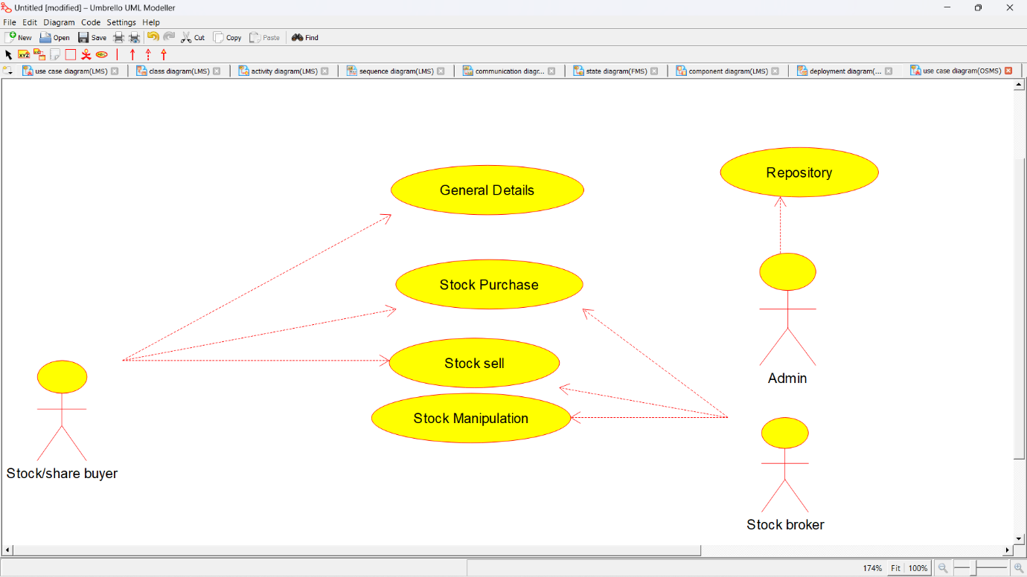

**CLASS DIAGRAM:** 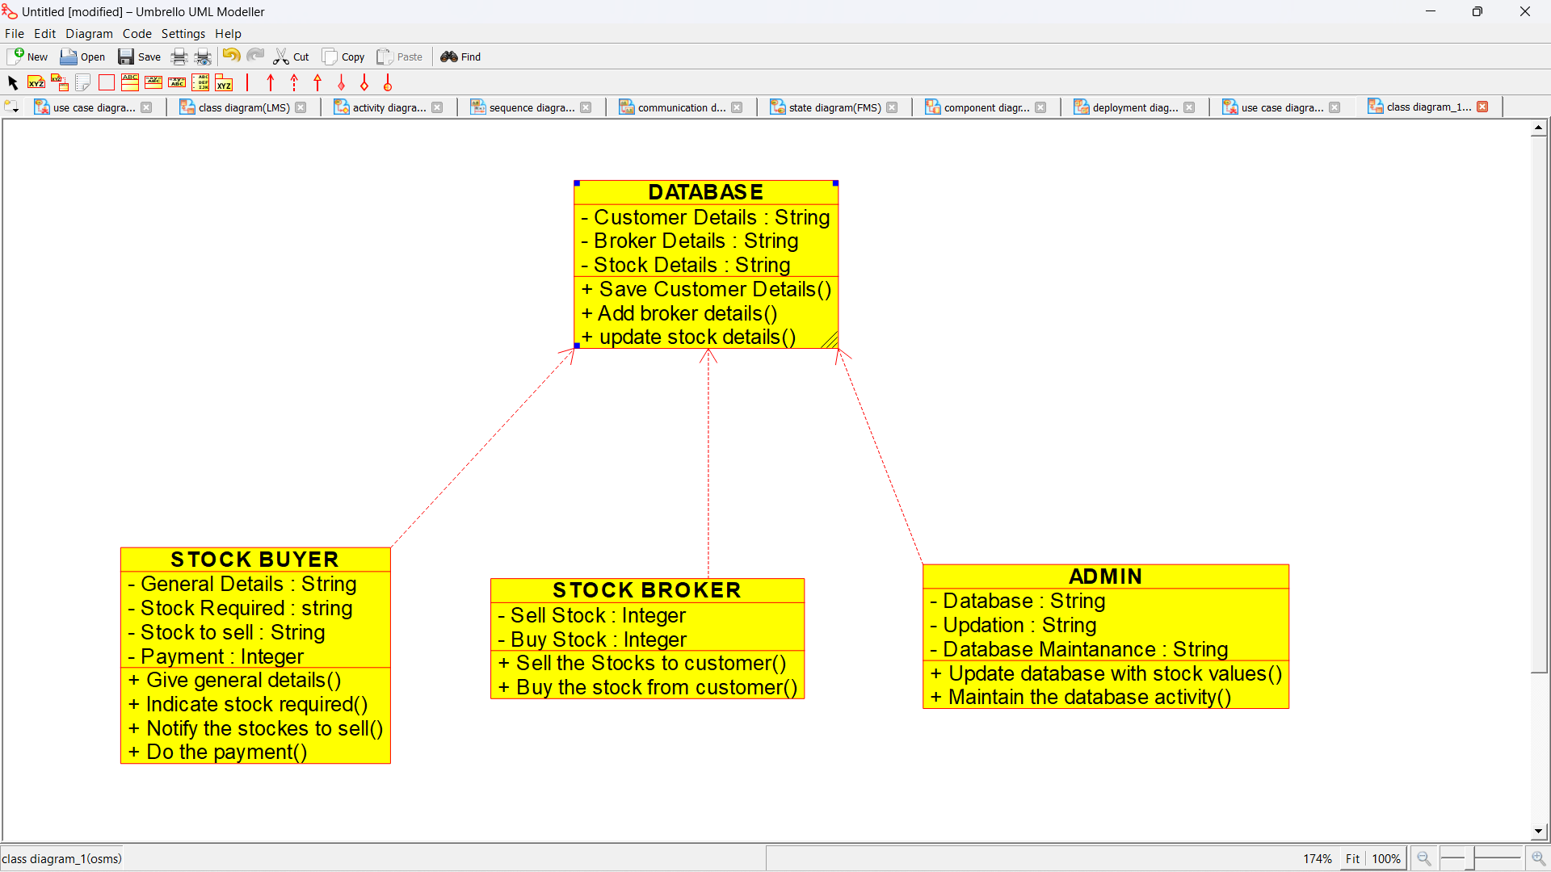

**ACTIVITY DIAGRAM:**

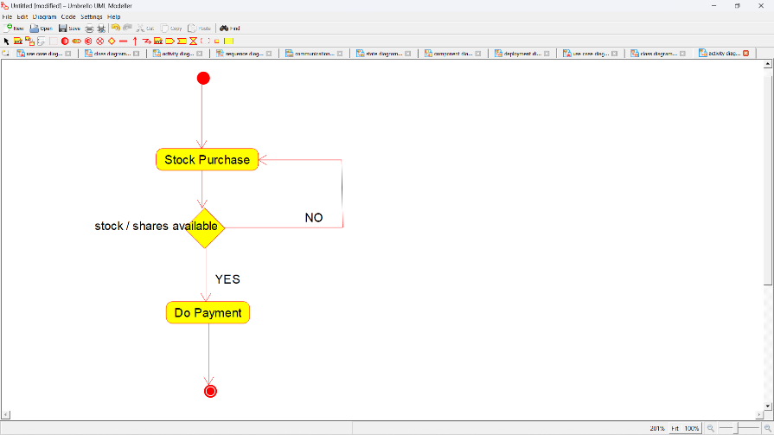

**SEQUENCE DIAGRAM:**

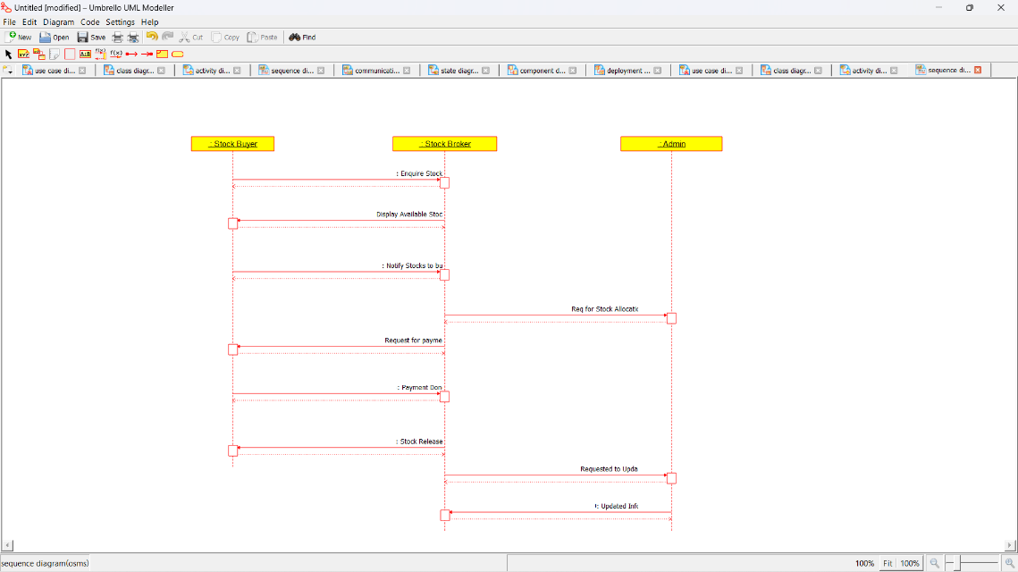

**COLLABORATION DIAGRAM:**

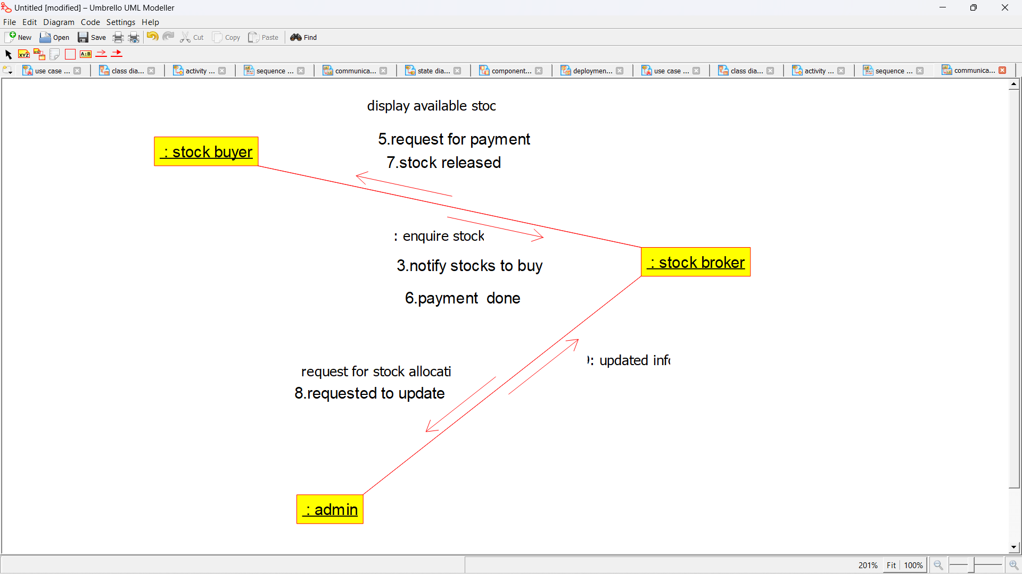

**STATE CHART DIAGRAM:**

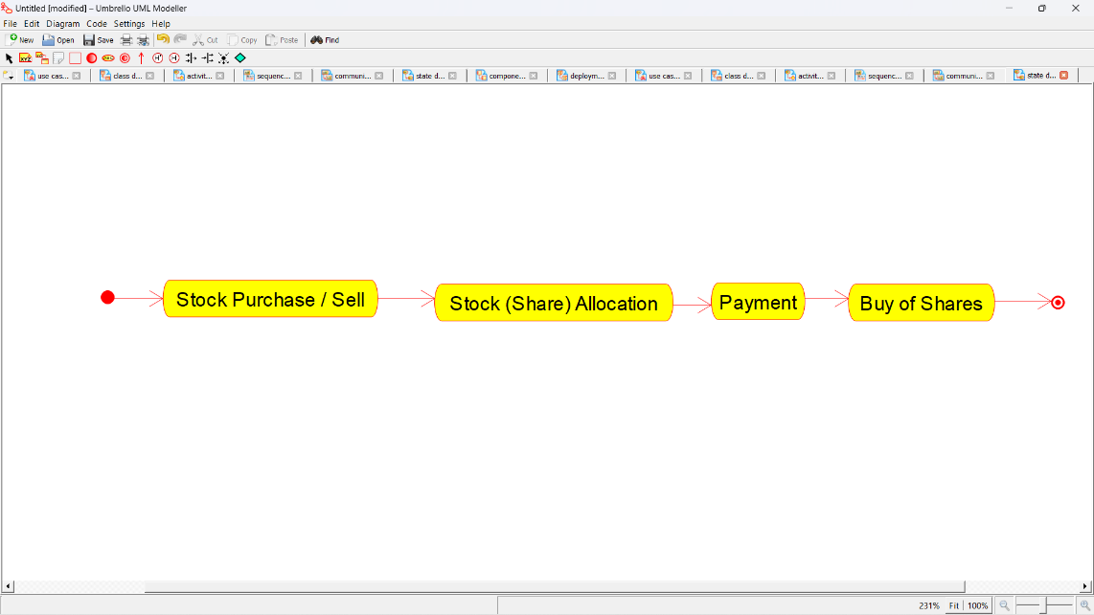

**COMPONENT DIAGRAM:**

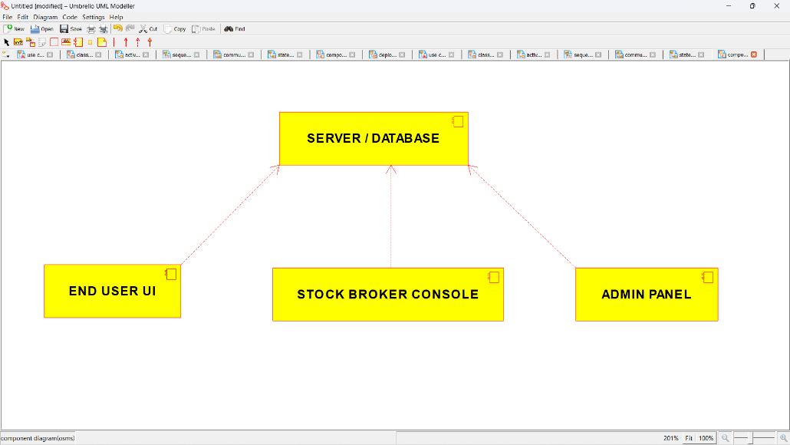

**DEPLOYMENT DIAGRAM:**

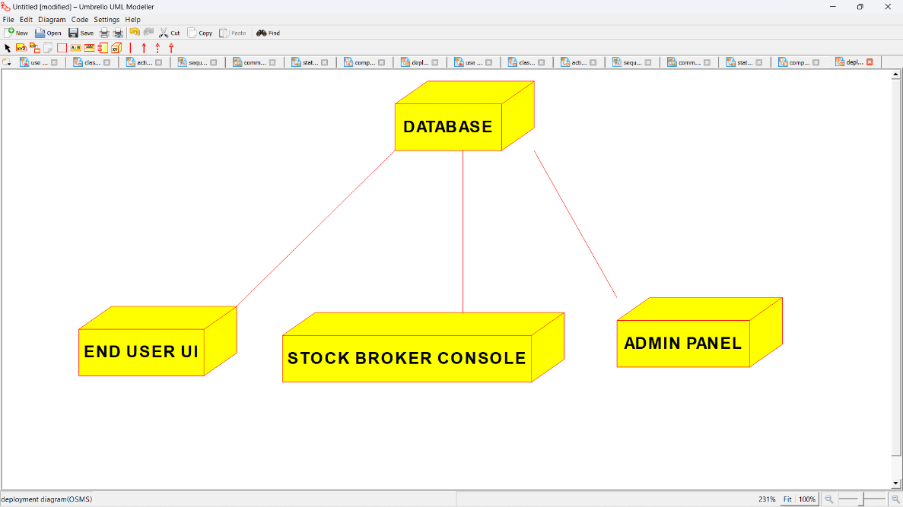

**PROGRAM CODING:**

**/\*\***

**\* Class ADMIN**

**\*/**

**public class ADMIN {**

**//**

**// Fields**

**//**

**private String Database;**

**private String Updation;**

**private String Database_Maintanance;**

**//**

**// Constructors**

**//**

**public ADMIN () { };**

**//**

**// Methods**

**//**

**//**

**// Accessor methods**

**//**

**/\*\***

**\* Set the value of Database**

**\* @param newVar the new value of Database**

**\*/**

**private void setDatabase (String newVar) {**

**Database = newVar;**

**}**

**/\*\***

**\* Get the value of Database**

**\* @return the value of Database**

**\*/**

**private String getDatabase () {**

**return Database;**

**}**

**/\*\***

**\* Set the value of Updation**

**\* @param newVar the new value of Updation**

**\*/**

**private void setUpdation (String newVar) {**

**Updation = newVar;**

**}**

**/\*\***

**\* Get the value of Updation**

**\* @return the value of Updation**

**\*/**

**private String getUpdation () {**

**return Updation;**

**}**

**/\*\***

**\* Set the value of Database_Maintanance**

**\* @param newVar the new value of Database_Maintanance**

**\*/**

**private void setDatabase_Maintanance (String newVar) {**

**Database_Maintanance = newVar;**

**}**

**/\*\***

**\* Get the value of Database_Maintanance**

**\* @return the value of Database_Maintanance**

**\*/**

**private String getDatabase_Maintanance () {**

**return Database_Maintanance;**

**}**

**//**

**// Other methods**

**//**

**/\*\***

**\*/**

**public void Update_database_with_stock_values()**

**{**

**}**

**/\*\***

**\*/**

**public void Maintain_the_database_activity()**

**{**

**}**

**}**

**/\*\***

**\* Class DATABASE**

**\*/**

**public class DATABASE {**

**//**

**// Fields**

**//**

**private String Customer_Details;**

**private String Broker_Details;**

**private String Stock_Details;**

**//**

**// Constructors**

**//**

**public DATABASE () { };**

**//**

**// Methods**

**//**

**//**

**// Accessor methods**

**//**

**/\*\***

**\* Set the value of Customer_Details**

**\* @param newVar the new value of Customer_Details**

**\*/**

**private void setCustomer_Details (String newVar) {**

**Customer_Details = newVar;**

**}**

**/\*\***

**\* Get the value of Customer_Details**

**\* @return the value of Customer_Details**

**\*/**

**private String getCustomer_Details () {**

**return Customer_Details;**

**}**

**/\*\***

**\* Set the value of Broker_Details**

**\* @param newVar the new value of Broker_Details**

**\*/**

**private void setBroker_Details (String newVar) {**

**Broker_Details = newVar;**

**}**

**/\*\***

**\* Get the value of Broker_Details**

**\* @return the value of Broker_Details**

**\*/**

**private String getBroker_Details () {**

**return Broker_Details;**

**}**

**/\*\***

**\* Set the value of Stock_Details**

**\* @param newVar the new value of Stock_Details**

**\*/**

**private void setStock_Details (String newVar) {**

**Stock_Details = newVar;**

**}**

**/\*\***

**\* Get the value of Stock_Details**

**\* @return the value of Stock_Details**

**\*/**

**private String getStock_Details () {**

**return Stock_Details;**

**}**

**//**

**// Other methods**

**//**

**/\*\***

**\*/**

**public void Save_Customer_Details()**

**{**

**}**

**/\*\***

**\*/**

**public void Add_broker_details()**

**{**

**}**

**/\*\***

**\*/**

**public void update_stock_details()**

**{**

**}**

**}**

**/\*\***

**\* Class STOCK_BROKER**

**\*/**

**public class STOCK_BROKER {**

**//**

**// Fields**

**//**

**private Integer Sell_Stock;**

**private Integer Buy_Stock;**

**//**

**// Constructors**

**//**

**public STOCK_BROKER () { };**

**//**

**// Methods**

**//**

**//**

**// Accessor methods**

**//**

**/\*\***

**\* Set the value of Sell_Stock**

**\* @param newVar the new value of Sell_Stock**

**\*/**

**private void setSell_Stock (Integer newVar) {**

**Sell_Stock = newVar;**

**}**

**/\*\***

**\* Get the value of Sell_Stock**

**\* @return the value of Sell_Stock**

**\*/**

**private Integer getSell_Stock () {**

**return Sell_Stock;**

**}**

**/\*\***

**\* Set the value of Buy_Stock**

**\* @param newVar the new value of Buy_Stock**

**\*/**

**private void setBuy_Stock (Integer newVar) {**

**Buy_Stock = newVar;**

**}**

**/\*\***

**\* Get the value of Buy_Stock**

**\* @return the value of Buy_Stock**

**\*/**

**private Integer getBuy_Stock () {**

**return Buy_Stock;**

**}**

**//**

**// Other methods**

**//**

**/\*\***

**\*/**

**public void Sell_the_Stocks_to_customer()**

**{**

**}**

**/\*\***

**\*/**

**public void Buy_the_stock_from_customer()**

**{**

**}**

**}**

**/\*\***

**\* Class STOCK_BUYER**

**\*/**

**public class STOCK_BUYER {**

**//**

**// Fields**

**//**

**private String General_Details;**

**private String Stock_Required;**

**private String Stock_to_sell;**

**private Integer Payment;**

**//**

**// Constructors**

**//**

**public STOCK_BUYER () { };**

**//**

**// Methods**

**//**

**//**

**// Accessor methods**

**//**

**/\*\***

**\* Set the value of General_Details**

**\* @param newVar the new value of General_Details**

**\*/**

**private void setGeneral_Details (String newVar) {**

**General_Details = newVar;**

**}**

**/\*\***

**\* Get the value of General_Details**

**\* @return the value of General_Details**

**\*/**

**private String getGeneral_Details () {**

**return General_Details;**

**}**

**/\*\***

**\* Set the value of Stock_Required**

**\* @param newVar the new value of Stock_Required**

**\*/**

**private void setStock_Required (String newVar) {**

**Stock_Required = newVar;**

**}**

**/\*\***

**\* Get the value of Stock_Required**

**\* @return the value of Stock_Required**

**\*/**

**private String getStock_Required () {**

**return Stock_Required;**

**}**

**/\*\***

**\* Set the value of Stock_to_sell**

**\* @param newVar the new value of Stock_to_sell**

**\*/**

**private void setStock_to_sell (String newVar) {**

**Stock_to_sell = newVar;**

**}**

**/\*\***

**\* Get the value of Stock_to_sell**

**\* @return the value of Stock_to_sell**

**\*/**

**private String getStock_to_sell () {**

**return Stock_to_sell;**

**}**

**/\*\***

**\* Set the value of Payment**

**\* @param newVar the new value of Payment**

**\*/**

**private void setPayment (Integer newVar) {**

**Payment = newVar;**

**}**

**/\*\***

**\* Get the value of Payment**

**\* @return the value of Payment**

**\*/**

**private Integer getPayment () {**

**return Payment;**

**}**

**//**

**// Other methods**

**//**

**/\*\***

**\*/**

**public void Give_general_details()**

**{**

**}**

**/\*\***

**\*/**

**public void Indicate_stock_required()**

**{**

**}**

**/\*\***

**\*/**

**public void Notify_the_stockes_to_sell()**

**{**

**}**

**/\*\***

**\*/**

**public void Do_the_payment()**

**{**

**}**

**}**